**Check_mode:**

* If we use - - check at the end of command executing ansible playbook. It will let us know what will happen after running the yml. This we use when we try to run yml file in prod servers
* **Ansible-playbook filename.yml - -check**
* From version 2.2, we can force a task to always run in check mode
* For that, we need to use **“ check_mode=yes or no “**

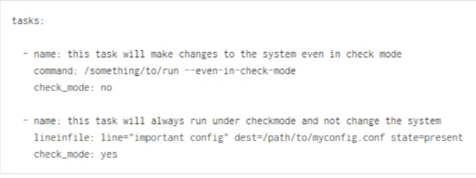

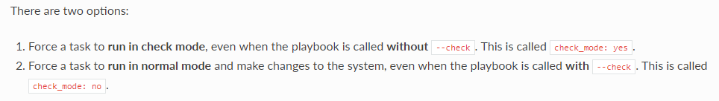

* Anything which is dependent on result of something, put check_mode as no there

**Prompt/Interactive mode:**

* When running a playbook, you may wish to prompt the user for certain input, and can do so with the ‘vars_prompt’ section.
* A common use for this might be for asking for sensitive data that you do not want to record.
* This has uses beyond security, for instance, you may use the same playbook for all software releases and would prompt for a particular release version in a push-script.

**Examples:**

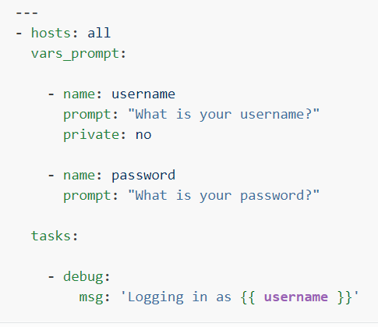

* By default, user input data will be hidden. If we want to make it visible. We can user “private=no”

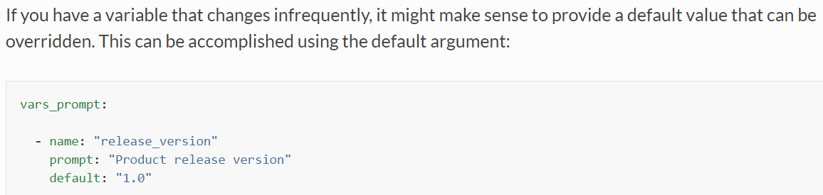

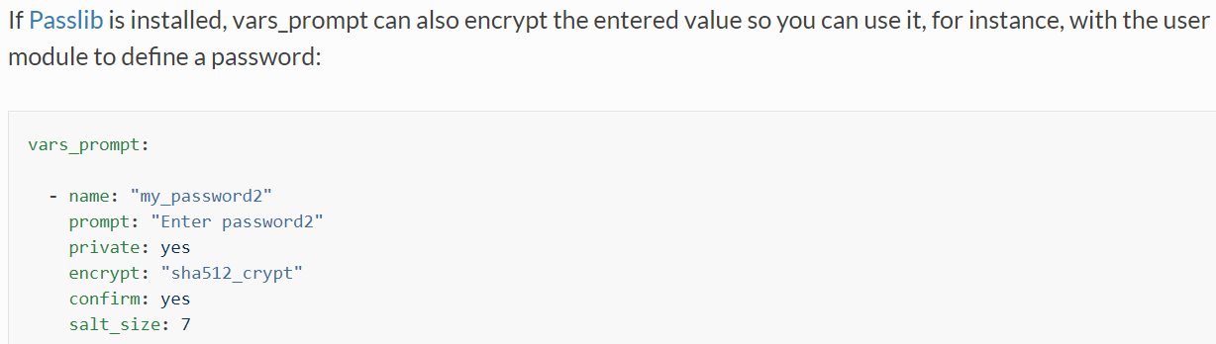

* This is not good for automation; we cannot do it with cronjobs